**Project Report: Machine Failure Prediction Using Sensor Data**

**1.Introduction**

Equipment issues can lead to periods of inactivity and increased operational costs. Predictive maintenance aims to predict these issues in advance to enable repairs and reduce unexpected breakdown incidents. This research employs machine learning techniques to forecast failures using sensor data from various equipment.

**2. Dataset Overview**

The dataset consists of sensor data collected from various machines. The goal is to predict machine failures in advance using these sensor readings.

**2.1 Columns Description**

* footfall: The number of people or objects passing by the machine.
* temp Mode: The temperature mode or setting of the machine.
* AQ: Air quality index near the machine.
* USS: Ultrasonic sensor data, indicating proximity measurements.
* CS: Current sensor readings, indicating the electrical current usage of the machine.
* VOC: Volatile organic compounds level detected near the machine.
* RP: Rotational position or RPM (revolutions per minute) of the machine parts.
* IP: Input pressure to the machine.
* Temperature: The operating temperature of the machine.
* fail: Binary indicator of machine failure (1 for failure, 0 for no failure).

**3. Data Preprocessing**

The initial steps in data preprocessing involve loading the data, inspecting its structure, and handling missing values.

**3.1 Loading and Inspecting Data**

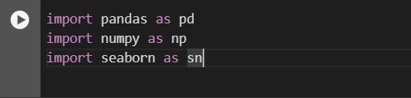



**3.2 Checking for Missing Values**



**3.3 Splitting the Data**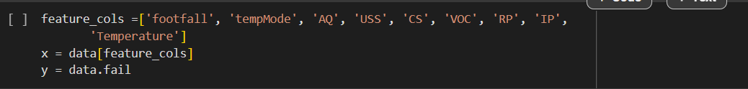

**4. Model Training**

A Logistic Regression model is used for predicting machine failures.

**4.1 Training the Model**





**4.2 Making Predictions**



**5. Model Evaluation**

The performance of the model is evaluated using various metrics such as confusion matrix, accuracy score, and R² score.

**5.1 Confusion Matrix**



**5.2 Accuracy Score**

**5.3 R² Score and Mean Squared Error**



**6. Data Visualization**

**6.1 Correlation Matrix**

**6.2 Scatter Plot of Predictions**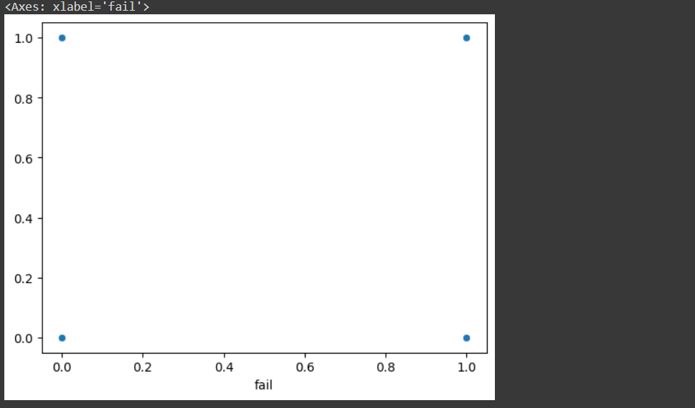

**7. Conclusion**

One way to anticipate machine malfunctions is by using the Logistic Regression technique as a foundation for analysis and prediction tasks. The effectiveness of this method is proven through its precision and R squared values; however further enhancements, through feature enhancement. The exploration of advanced machine learning techniques are options worth considering to maximize improvements. 